Genesis-7 SUPERPOWER TBC

Muhammad Qorano Wanggai, Madi Crowley-Long, Junyi Song

T1 2023

SIT383

Contents

Proposed Superpower & User Stories 2

Enhanced Reality Classification (MW) 3

Nature of Reality 3

Location (setting) 3

Objects 4

Interaction and Feedback 4

Concepts explored 5

Participant engagement 5

Design of experience 6

Nature of Reality 6

Location (Setting) 6

Interaction with Objects 7

Interaction & Feedback Strategy 7

Concepts Communicated by the Experience 8

Participant Engagement 8

Style of Experience 8

Equipment (MW & MCL) 9

Design Solution (MW) 9

Design Solution (MCL) 10

Next Steps 10

Each section indicates where Muhammad (MW), Madi (MCL) and Junyi Song (JS) entered content.

# Proposed Superpower & User Stories

## Elemental Control

The power of elemental control is crucial in today’s global warming crisis. We are increasingly experiencing unprecedented high temperatures, flooding, record low temperatures, unusual snow and freezing over, droughts etc.

The user will be able to call upon the elements or influence those already present e.g.

* move or shape bodies of water
* heat rooms, people or objects
* cool rooms, people or objects
* harness wind/air to cool things or move them

## Goals/Potential Uses (MCL, MW, JS)

1. Public Service – the focus of the superpower could be directed towards summoning water from deep in the Earth or from local water sources to water crops in drought-affected farming areas. Another public service could be heating a space to create an environment where homeless people can sleep and be warm in the winter – challenges with this would be how the heat would then be maintained. Would the user have to stay and keep bringing heat and warmth or could multiple people rotate through? Would rely on volunteering capacity as food kitchens etc do.
2. Sports – the user could be part of a groundskeeping type team for sports that rely on fair weather to play – a team of people with this superpower could ensure golf, tennis or other outdoor sports go ahead after heavy rain by removing moisture from fields or outdoor courts.
3. Science Education – the science behind the superpower could be discussed in theory (e.g. the heating element really just being making the molecules vibrate at a higher frequency), and then shown in practice to students as they are able to use those superpowers. This would create a highly engaging experience where students are much more likely to remember the theory with such an interactive practical element involved.
4. Personal Convenience – being able to cool a room via a self-made breeze on a hot day, dry out clothes as soon as they’ve come out of the washing machine by removing moisture, heat up a bed before going to sleep without the need for an electric blanket or mattress or even just heat up food that’s been in the fridge without having to have a microwave or cool down food that’s come right out of the oven/pan.
5. Fun – being able to propel a sailing boat in any given direction by controlling the wind, being able to have a water fight with people without the need for water balloons by ‘throwing’ water using water shaping and wind control, setting up a layer of frost or snow on a hill to allow for snowfights or skiing/snowboarding in otherwise unthinkable places etc.

## User Stories 1.0 (MCL, MW, JS)

**(Personal Convenience)**

It is summer in Queensland, which has brought record levels of humidity and high temperatures. To reduce carbon emissions and save money on an already skyrocketing power bill, Jade is able to harness the elements and create a natural breeze through her home on an otherwise stifling day.

One week, there is a huge series of thunderstorms. The extra humidity in the air permeates the whole house, creating risks of mould spores growing in the ceiling, on clothing and in other unexpected places. To make sure her house stays safe, Jade walks around her home 2-3 times a day, extracting moisture in each room from everything around her, before expelling it back outside into her backyard.

She channels this extra moisture to form a natural stream running from her back fence down the side of her house, creating a backyard water feature that would otherwise have taken thousands of dollars for landscapers to introduce.

# Exploratory Enhanced Reality Classification (MCL)

## Nature of Reality

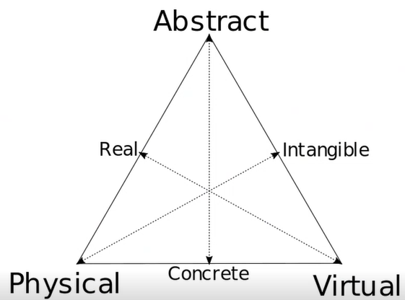

*(Physical = 0.4, Abstract = 0.2, Virtual = 0.4)*

This setting would be a mix of the physical and virtual world – the physical world around the user, what they can see, is the limit of what they can interact with. The superpower can only be used with elements within a certain radius of the user – the further away an element or object being influenced is, the harder it is to influence it as the user’s reach has to go through so many more molecules to get there.

The virtual element would be the way in which the superpower is impacting things around the user and how the user would sense this e.g. if there is air control occurring, the sound of a breeze or wind blowing would let the user know. Potentially the user could feel a breeze blowing on them as they harness wind control, which could be a VR element that would involve physical fans that aren’t visible to the user in their virtual space.

The abstract element could refer to the need for the user to be able to visualise moisture in the ground or in other settings where it isn’t always entirely visible (e.g. high humidity rating but no actual physical rain).

## Location (Setting)



*(Physical = 1.0, Abstract = 0.0, Virtual = 0.0)*

This experience could take place in the physical world. To do this the user would probably have to be in a pre-defined setting, with fans set up in various points around the room to be able to simulate the wind control element. There could also potentially be jets at various points in water features throughout the room so that if the user gestured, water could rise up and be sent in different directions. Heating or cooling pads on objects and at various points around the landscape could simulate the temperature control.

A purely physical setting would present challenges and limitations both logistically and financially, but with the right funds and the aforementioned tech, could theoretically be set up and utilised. A purely physical setting would make it hard to satisfy many of the goals mentioned in the previous section, outside of potentially using the superpower for fun.

## Interaction with Objects



*(Physical = 0.5, Virtual = 0.35, Abstract = 0.15*

With this sort of approach, objects would largely be interacted with physically by the user, although there would be virtual objects involved.

Regular objects would be whatever was around the user at the time and could be manipulated as if there was no superpower at play.

Virtual objects could be the water that the user is controlling – the user could be working in an AR space that allows them to use gestures to show water objects being formed and manipulated in the virtual world, but taken from water sources in the physical realm.

The abstract element could relate to the air manipulation – there might be audio present but no visible representation of wind manipulation at play if there’s nothing light enough to be moved, leaving the user with a need to imagine the wind manipulation. This would only apply if it was an AR scenario. Abstraction could drop to 0 if it was a VR scenario and the air manipulation could be managed by various fans etc at the VR facility.

## Interaction & Feedback Strategy



*(Physical = 0.3, Virtual = 0.6, Abstract = 0.1)*

This point on the schema represents an interaction and feedback strategy that is largely virtual.

This could relate to a VR set-up where the user is physically touching a water source and then lifting their arm as a virtual gesture – this would set off a pressure jet and the user would be able to physically feel the water fly up and land on them if they’d directed it to go that way.

The virtual elements would form the main focus of this set-up and would be related to gestures for performing elemental manipulation – that could be free movement full body or hand gestures in a VR setting if the user was in some sort of suit or sensor-based system.

An abstract element could relate to the need of the user to interpret which way their wind manipulation has gone – judgement could be based on movement of leaves, water flows, ripples on still water etc, with the user then being able to make sure the wind manipulation has gone according to plan for them or work out which way they need to gesture and how hard to do what they’re aiming for.

## Concepts Communicated by the Experience

*(Physical = 0.7, Virtual = 0.3, Abstract = 0.0)*

In this instance the concepts would be largely physical, with some virtual elements at play. The main concepts that need to be communicated are things that signal the superpower is in use, as well as things that show the impact the superpower has had on the surrounding objects and landscape.

To achieve this, the user could have temperature features of element control communicated physically through heating/cooling sources on certain objects or features that are activated when the user tries to use their superpower. A virtual component of this might be an overlaid change in the object or area’s colour to help the user identify that this superpower has been activated in that particular area.

## Participant Engagement

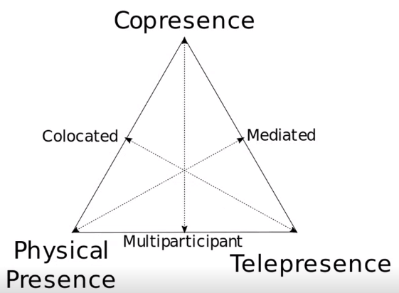

*(Physical Presence = 0.5, Copresence = 0.5, Telepresence = 0.0)*

Participants in this instance might be in the same physical setting and their superpower moves might impact one another e.g. one user might control the wind to flow one way, impacting what the other user was trying to do with some water control. This could be simultaneous e.g. in the same setting at the same time, or it could be that one user has set up water to flow a certain way with their power or heated an area, and after the fact, another user comes along and changes this set up using their own powers.

## Style of Experience

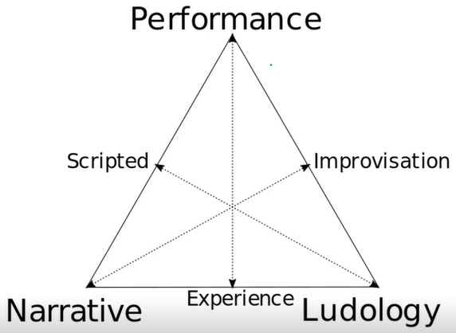

*(Narrative = 0.4, Ludology = 0.2, Performance = 0.4)*

This set-up could involve a narrative and story arc where the user is directed to use their superpower for the betterment of others. This could be fictional or real-world scenarios that would then link into the Public Service goals potentially. There could then be an element of role-play as the user is given an opportunity to be a landscaper, a firefighter, a sailor, or all sorts of things that could be enhanced by having elemental control.

Gamification could mean that there are certain segments or sections where the user is given a goal, as mentioned above in some of the role-playing scenarios, and then can still have free use of any of their superpowers. This could mean instead of using their water power to fight fire, they might use air/wind control to remove oxygen from the area around the fire, thereby extinguishing it in an unexpected but still allowed fashion.

# Exploratory Enhanced Reality Classification (MW)

## Nature of Reality

= The participant will be able to experience the conjuration superpower through an augmented reality system, which means the participant’s nature of reality will be set between the physical and virtual world. With the utilization of augmented reality systems, the participant’s physical world can be integrated with virtual elements and objects.

## Location (setting)

= The experience will take place in the real/physical world based on where the participant is, with virtual elements added on the top of it by the augmented reality system.

## Objects

= While the experience is set in the real/physical world, the objects will be completely virtual. The virtual objects will be generated by the augmented reality system that the participant is using. The virtual objects in this sense will be the things that the participant is able to summon with their “superpower”.

## Interaction and Feedback

= The participant will be able to engage with the experience through the augmented reality system, which is a smartphone. The smartphone’s AR feature is able to capture the participant’s environment through a camera then integrating it with virtual elements such as generating virtual objects. To summon these virtual objects, the participant has to tap on a button provided in the UI of the AR experience in their smartphone. After tapping the button, a virtual object will be generated on top of the participant’s environment based on their movement through the AR system.

## Concepts explored

= The experience will rely on technology, both hardware and software. The AR features, especially on generating the virtual objects, will be developed through Unity software. These features then will be integrated with the participant’s physical environment through a smartphone which will be the hardware. The smartphone must require a camera and a motion-tracking gyroscope in order to accurately track the participant’s movement and placement.

## Participant engagement

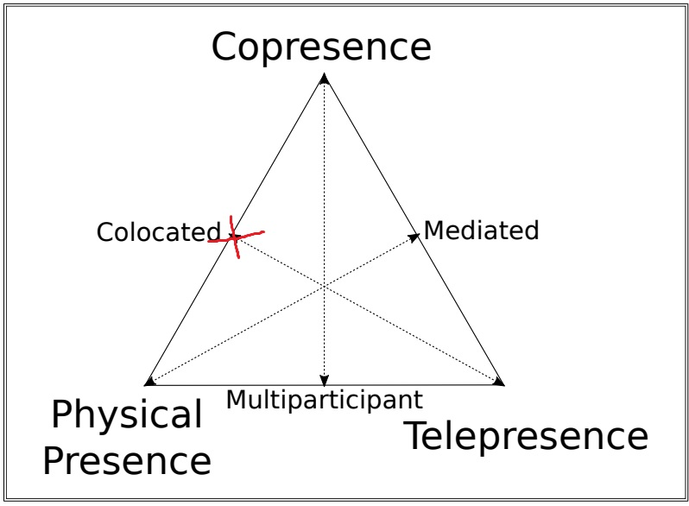

= By the use of the augmented reality system the participant will be present wherever location they are, while engaging with the AR experience and features at the same time. The experience will be focused on the sole participant only.

## Design of experience

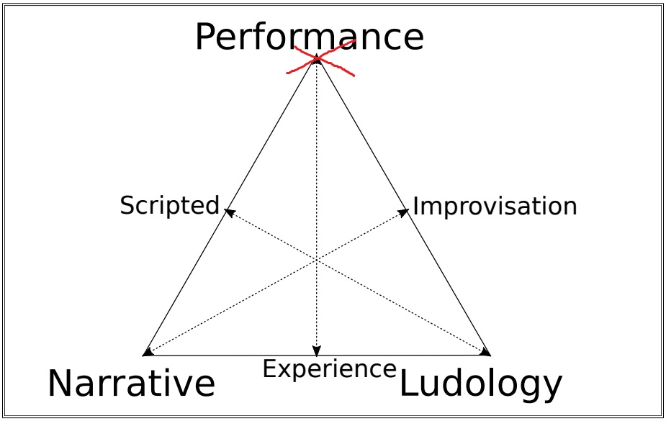

= The experience will let the participant to freely experiment with their “superpowers” of conjuring virtual objects around their environment without the requirement of fulfilling certain objectives or following narrative structures.

# Potential Design Solution (MCL)

A potential solution could be a virtual reality system that allows the user to demonstrate their super powers with some physical elements to feel the impact of those powers. It would have to be at a specific physical location.

**Goal:** Science Education

**Platform**: Oculus Quest headset coupled with physical effects set up at location

**Example User Story:** Lewis is part of a group of school students who are learning about chemical composition and the environment. His class has been covering molecular composition and state changes.

Lewis’ teacher takes them to the VR set-up. Within this Oculus Quest environment, Lewis can gesture to water and have it rise up. He can also bring some up to in front of him and shape it with gestures from both hands as if it were clay, demonstrating the nature of water in its liquid state.

He can turn a virtual dial and then utilise gestures to direct heat or cooling at water sources, watching as the water changes state from liquid to solid ice. If he touches the ice, a zoomed in perspective is brought up on screen that provides a graphic of the molecules and how close together they are, as well as a brief written description of the molecular activity whilst in that state. Similarly, a perspective can be provided if the temperature has been turned up and the water is turned to steam.

Air manipulation can help Lewis and other students understand that despite being invisible, the air around them is in fact filled with tiny molecules and that, when gathered together, these molecules have the capacity to move things just as much as the molecules of more visible solid objects. To demonstrate this, a verbal command “Wind Power” is issued by Lewis that then changes the outcome of gestures. Swinging arms in one direction or another changes the wind movement in that direction, pushing loose leaves around and creating ripples on still water etc. Similar to the water zoom feature, Lewis can pause and zoom in to see a close-up version of the molecules at work, with the wind molecules compressing as they push up against the leaves or water and forces symbolised etc.

The wind power element is represented by a series of fans installed at 8 points throughout the room (think 8 key points on a compass) as well as a fan under the floor and a ceiling fan. These can be turned on/off by Lewis’ gestures as mentioned above to simulate the wind control effect.

As elements are heated/cooled by the superpower, a series of water channels just under the floor and behind the walls can be heated/cooled at various locations to represent heat or coolness emanating from an object that might be in that location.

**Limitations:** The solution relies on students having use of their arms as well as being comfortable wearing a headset, which could be limiting for some students with disabilities.

The heating/cooling channels mentioned would only be able to work with objects or locations directly on the floor/near the walls. For features like water that has been manipulated by the user to rise up and take shape in front of them, the temperature representation wouldn’t work.

From a more practical perspective, none of Muhammad, myself or Junyi have access to an Oculus set to test prototypes and code, which makes this highly challenging to implement as a concept.

# Potential Design Solution (MW)

# Potential Design Solution (JS)

# Final Design Solution (All)

## Overview

The final discussed and agreed upon design is an augmented reality system where the user can utilise the mobile front and back camera as well as the gyroscope for gestures to activate their elemental control superpower on their surroundings. The superpower of elemental control will include:

* Air control
* Water control
* Temperature control

**Goal:** Public service – once the user has familiarised themselves with the controls, the application/game will use geolocation features to create ‘crisis moments’ where the user can influence things with their elemental control to save the day. This could be built out into a fully gamified system with points, levels and increased elemental control features eventually.

**Hardware Selection:** The system will run as an AR system on Android devices – this choice was largely limited due to no team member owning an Oculus Quest. It will utilise the phone’s front camera, back camera and gyroscope. It will also link in with Google Maps data to create the aforementioned ‘crisis points’.

## User Story

Sam is sitting out on his back deck in winter, well rugged up. Snow is falling around him as he looks out at the park that backs onto his property. He suddenly notices a small dog trying to fight its way through the snow out in the park. The dog looks alone and very tired and cold.

Jumping off his back deck, Sam dashes over to the dog. He uses the voice command “Heating activation” to turn on his temperature control superpower and set it to heat mode. With a point of his finger in front of him at the dog, a stream of warmth begins to flow. The dog visibly becomes warmer, with bits of frost falling off of it and shaking ceasing.

The dog is also covered in dirt and grime. Sam looks around and spots a nearby tap that hasn’t quite frozen over. He points at the tap and says “water control activation”. Water begins to flow out of the tap. Sam pulls it towards himself with a gesture of his arm and the water comes towards him. He puts out his hand with a ‘stop’ type signal and switches back to heat activation using the same command as earlier. He points at the water hovering mid-air and heats it, then gently gestures with his arm to move the water down and onto the dog so he can wash it with warm water.

As the dirt begins to wash away, the dog starts shivering again – the winter breeze has picked up and is drying the water off, making the poor animal cold. Sam activates his wind control (“Wind control activation”) and uses a ‘stop’ gesture in front of him to kill the breeze from any direction, stilling the air.

With the dog now saved and the public crisis averted, Sam checks his map and notices there is another public crisis alert at a nearby local landmark. He heads off in that direction to assist, utilising his map to ensure he is heading the right way.

Sam continues in this fashion from landmark to landmark (or crisis to crisis), gradually building up his skills of elemental control.

## Classification

**Nature of Reality**: This solution will be a mix of physical and virtual, largely virtual. It will rely on the physical world around the user to create the base location elements but interactions and their impacts will occur virtually via the augmented reality system on a phone screen. We may potentially have a slight abstract element too in terms of where the user can draw water for their superpower from – it may be places where water isn’t visible but the user knows it is in e.g. deep in the earth or from air on a humid day.

**Location (Setting):** The experience will take place partly in the virtual world and partly in the physical world. As mentioned above, the physical location of the user will determine what elements can be impacted, but the outcome of using superpowers will exist solely in the virtual world.

**Interaction with Objects:** This will be largely virtual e.g. the water the user is controlling via gestures, freezing or heating up of objects and the impact it has on them will be purely virtual, with no physical impacts.

**Interaction & Feedback Strategy:** This will be virtual. Gestures will form a large component of the interactions in terms of using the superpower, while there will be some touch-screen features as well to change superpower or adjust what a gesture does (e.g. changing from a freezing power to a heating power). There will also be an abstract element in terms of wind control – not necessarily visible in itself on the screen but hopefully discernible by interpreting the movement of other elements shown on the screen.

**Concepts Communicated by the Experience:** The main concepts that need to be communicated are the impacts of the elemental control superpower. This will be virtual, as the effects of the superpower are only going to be visible on the screen. There could be considered to be a segment of physical, as the starting point for objects and their temperature or their state, does depend on the original physical setting.

**Participant Engagement:** Participants can be in the same physical setting, but their superpower moves at this stage will not impact one another. In future iterations it could be that there is a network-based telepresence component that allows users to view the impact of other people’s elemental control on a local area and combat this with their own.

**Style of Experience:** The application will involve a degree of narrative and structure to help the user familiarise themselves with the superpowers, elements they can influence, associated gestures. From here it will move to more of a sandbox and freeplay style, with the user able to use their superpower on any given local area they find themselves in, in any manner they wish.

We will also incorporate some gamification where there may be key goals around a landmark in the user’s local area e.g. a local crisis (fictional) where the user must go and try to use their superpowers to save the day. How they save the day would be entirely up to them e.g. they can freeze a river downstream to save someone from drowning or they can use air control to try to stop the flow of the river – the choice will be left to the user.

# Required Components

## #1 - Location (Setting) – Tracking your location globally using GPS

This component will be put to use to determine the user’s location and then link in with Component #2 to find nearby ‘crisis points’. The model could be similar to Niantic’s series of games that use landmarks from Google Maps to set up events.

## #2 - Location (Setting) – Presenting your setting using map tile services

This component will be used to access Google Maps data and determine where local landmarks are, showing them on a map that can come up on the user’s screen when required or requested.

## #3 – Location (Setting) – Aligning overlapping realities

This component will be used to align parts of the virtual world that have been impacted by the user’s elemental control, with their physical companions. For example, if a user turns up the heat on an object and melts it, but then moves the phone/camera and the scene changes, that melted virtual object should still align over the physical one in the new scene shown from the camera feed. That is, the virtual objects should align consistently to their physical companions.

## #4 – Objects for Interaction Components – Tracking the user and objects to allow interaction

The user’s elemental control will struggle to reach objects further away – objects closer will be impacted more heavily and sooner. This means there will be a need to track where the user is in relation to objects, and also to place superpower-impacted virtual objects at their accurate location in the world on camera in relation to the user.

## #5 – Objects for Interaction Components – Sensing the orientation of a device

Given the elemental control will rely largely on gestures, the orientation of the device will play a key role e.g. when the right settings are selected in-app, a turn of the device might cause wind to blow a certain way, or move the flow of water, or change the temperature control from hot to cold along a scale etc.

## #6 – Objects for Interaction Components - Synthetic buttons and dials for use in an augmented reality user interface

The user will have the ability to press buttons or turn dials that exist in the augmented space – these may do things such as change the elemental focus (wind, water, temperature) or change the intended temperature effect (heating vs cooling).

## #7 – Objects for Interaction Components – Identifying and recognising physical objects

This component will be useful for wind control – if there are loose leaves or other lighter items on the ground, they will need to be picked up and blown by the wind in the virtual space as the user controls it. This may also extend into trees moving in the breeze as well.

## #8 – Interaction and Feedback Components – Marker tracking with Vuforia

This component will relate heavily to the water manipulation feature. The user can ‘pick up’ water with their superpower, and then this water object will need to return back to its source when the user gestures for this to occur. This will require marker tracking as the water object hovers over its original source before being absorbed back in.

Marker tracking could also be relevant for determining where heating/cooling effects should be displayed on the screen and how these effects can stay in that position even as the camera moves.

## #9 – Interaction and Feedback Components – Speech recognition

The user will be able to use their voice to change the focus of the elemental power e.g. “Freeze mode” to switch to temperature control with a cooling setting and other similar voice commands for other modes. A “start”/”stop” feature can also be used for ongoing controls e.g. wind control or temperature control, rather than the user starting/stopping via gestures.

# Task Planner

MCL MW JS

All (individual completion)

All (group collaboration)

|  |  |  |  |  |  |  |  |  |
| --- | --- | --- | --- | --- | --- | --- | --- | --- |
| **Major Goal** | **Minor Task 1** | **Due Date** | **Minor Task 2** | **Due Date** | **Minor Task 3** | **Due Date** | **Minor Task 4** | **Due Date** |
| **Final Design Developed** | Review assignment 1 feedback | 2nd April | Review wk 4 documents and recording | 2nd April | Re-draft individual user stories and classification | 3rd April | Collaborate for final solution and task list | 5th April |
| Component #1 | Review learning material | 10th April | Prototype 1 (basic functionality) | 13th April | Prototype 2 (enhanced and tailored to elemental superpower) | 16th April | Final component form ready | 5th May |
| Component #2 | Review learning material | 17th April | Prototype 1 (basic functionality) | 19th April | Prototype 2 (enhanced and tailored to elemental superpower) | 22nd April | Final component form ready | 5th May |
| Component #3 | Review learning material | 23rd April | Prototype 1 (basic functionality) | 25th April | Prototype 2 (enhanced and tailored to elemental superpower) | 29th April | Final component form ready | 5th May |
| Component #4 | Review learning material | 10th April | Prototype 1 (basic functionality) | 13th April | Prototype 2 (enhanced and tailored to elemental superpower) | 16th April | Final component form ready | 5th May |
| Component #5 | Review learning material | 17th April | Prototype 1 (basic functionality) | 19th April | Prototype 2 (enhanced and tailored to elemental superpower) | 22nd April | Final component form ready | 5th May |
| Component #6 | Review learning material | 23rd April | Prototype 1 (basic functionality) | 25th April | Prototype 2 (enhanced and tailored to elemental superpower) | 29th April | Final component form ready | 5th May |
| Component #7 | Review learning material | 10th April | Prototype 1 (basic functionality) | 13th April | Prototype 2 (enhanced and tailored to elemental superpower) | 16th April | Final component form ready | 5th May |
| Component #8 | Review learning material | 17th April | Prototype 1 (basic functionality) | 19th April | Prototype 2 (enhanced and tailored to elemental superpower) | 22nd April | Final component form ready | 5th May |
| Component #9 | Review learning material | 23rd April | Prototype 1 (basic functionality) | 25th April | Prototype 2 (enhanced and tailored to elemental superpower) | 29th April | Final component form ready | 5th May |
| Combining features | Error-checking | 10th May | UX set-up, conducted and reviewed | 15th May | Pitch and demonstration planning | 20th May | Assessment items due | 22nd May |